# NATURAL LANGUAGE PROCESSING

**Team Infinity**

Aarya Garg (20UCS002) Harshal Jain (20UCS077) Suhani Sharma (20UCS202) Yash Jain (20UCS237)

Course Instructor

**Dr. Sakthi Balan Muthiah** Departmentof Computer Science Engineering The LNM Institute of Information Technology

# Project Round 1

Github Link:-<https://github.com/jYash2309/NLP_PROJECT_ROUND-1>

**Overview**

In this project, we will be analyzing the textbook by Russell and Norvig. We will next proceed and apply POS Tagging to the textbook. With the aid of Python libraries, we will use NLP frameworks to accomplish all of this.

## Book used

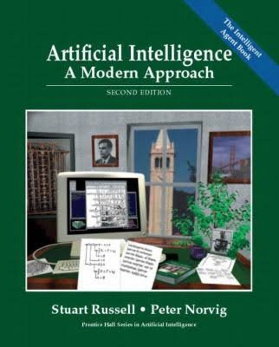

**Artificial Intelligence: A Modern Approach**

Textbook by Peter Norvig and Stuart J. Russell

## Goals

1. Import the text from the book in text format and call it ‘text’. (Tool used https://cloudconvert.com/pdf-to-txt)
2. Pre-process the text
3. Tokenize the text
4. Analyze the frequency distribution of tokens in the text
5. Create the Word Cloud using tokens
6. Remove the stopwords from text and again create a word cloud.
7. Compare frequencies with word clouds after removal of stopwords.
8. Analyzing the word length and evaluating the relationship between the word length and frequency for T1.
9. Do PoS Tagging for text and Get the distribution of various tags.

## Specifications

**Python Libraries used in this project**

* + Pandas - Used for data manipulation and analysis
  + NLTK - Used for Tokenizing, Lemmatization and Removing Stopwords
  + Re - Used to remove URLs and Decontract Contractions in English Language
  + Wordcloud - Used to create WordClouds from Tokenized Data
  + Inflect - Used to replace numbers with words
  + Maplotlib - Used to Visualize our text data

## Description Of Data

After converting the pdf into txt format the text looks like this

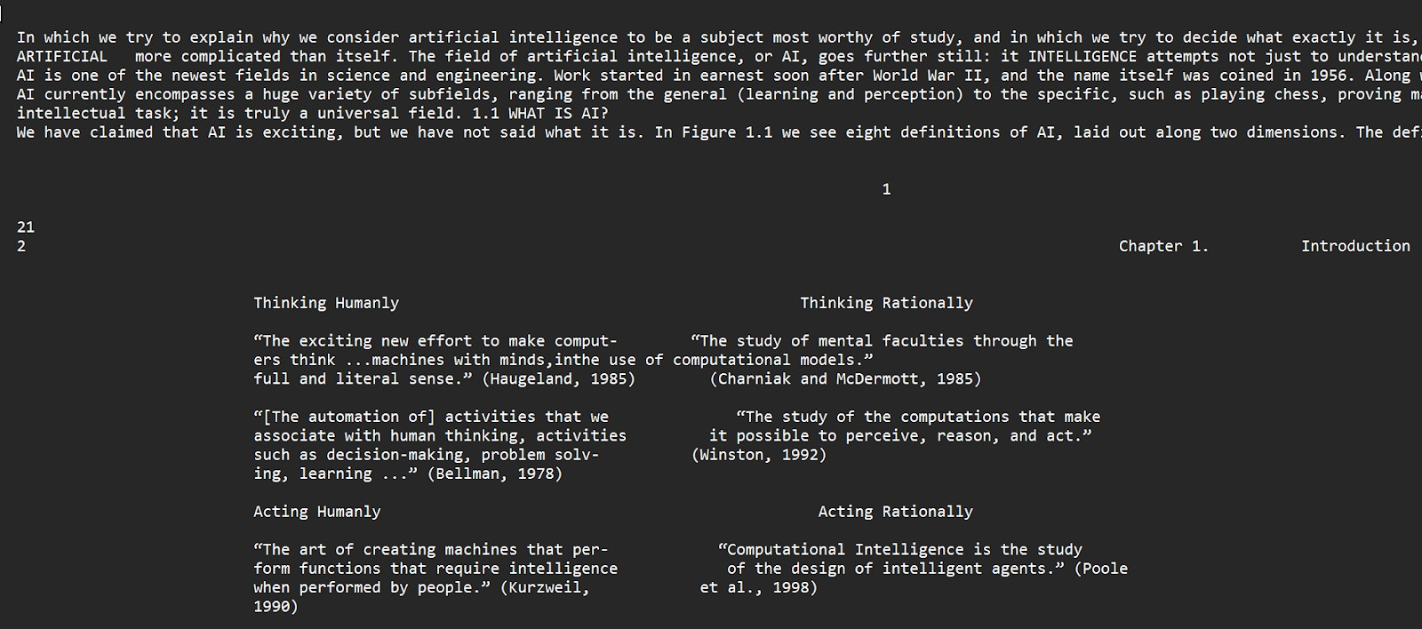

## Observations

1. There are certain numbers that are not immediately relevant to humans, therefore we must convert them to words.
2. In English, there are a lot of contractions and punctuation, and we need to turn them into useful data.
3. There are several special characters and URLs.
4. Emojis, emoticons, and chat phrases are not available

#THIS CAN BE IMPROVE

## Tasks

### Importing the book

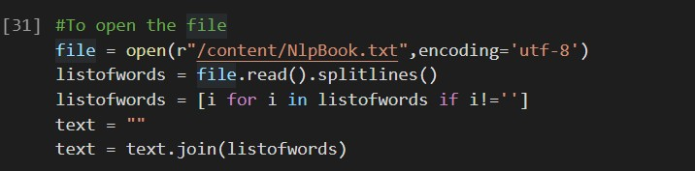

1. **Text Preprocessing Steps**

For preprocessing we have used following functions: -

* 1. Filtering the punctuations from the text and converting it into the lower case to make it relevant : -

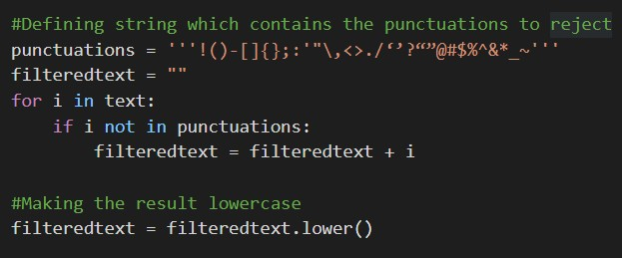

Now the text is filtered and labeled as ‘filteredtext’

### Tokenizing

Next, we tokenize the filtered text using the function ‘word_tokenize’ from the nltk.tokenize library.

* 1. Tokenizers divide strings into lists of substrings.
  2. This particular tokenizer ‘word_tokenize’ requires the Punkt sentence tokenization model to be installed.
  3. This Punkt sentence tokenizer divides text into a list of sentences by using an unsupervised algorithm to build a model for words.



**Using nltk.FreqDist() function to calculate the frequency of tokens**

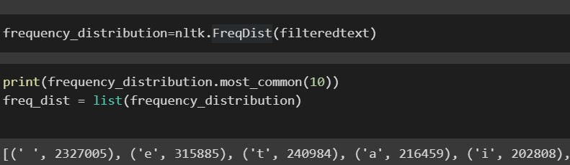

### Visualising the frequency distribution of tokens

We use **seaborn** plot to analyze the frequency of the tokens on our dataset. We check the first 25 most occurring tokens.

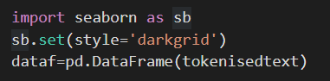

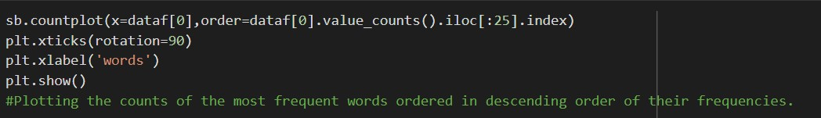

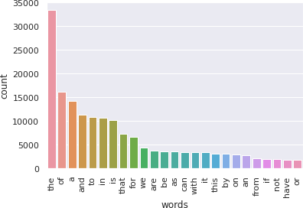

**Here most frequent words are plotted with their counts respectively**

### Creating word-cloud with Stop Words



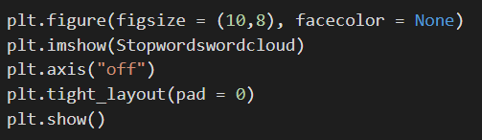

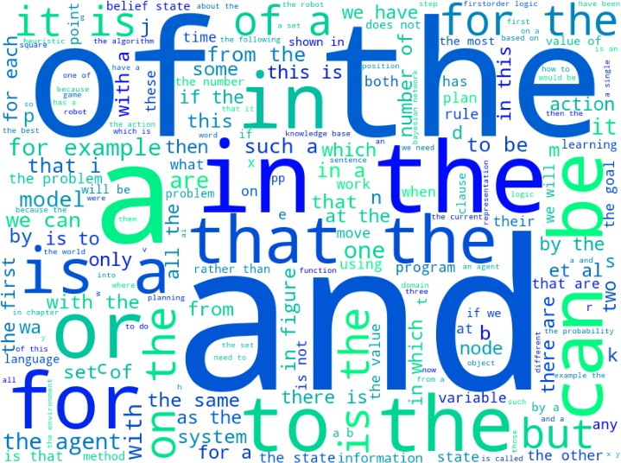

1. **Removing the Stop Words and again creating the word cloud**
   1. **Stop word removal :**

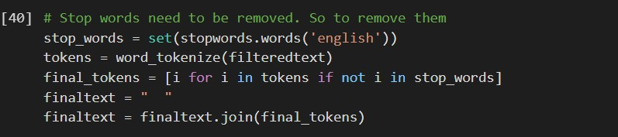

* 1. 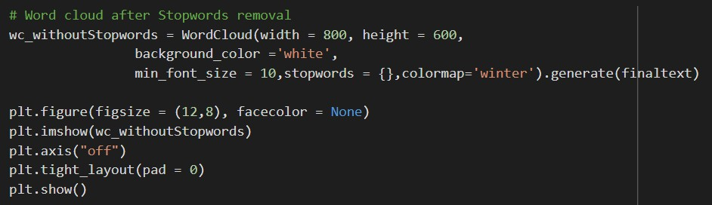**Creating the word cloud**

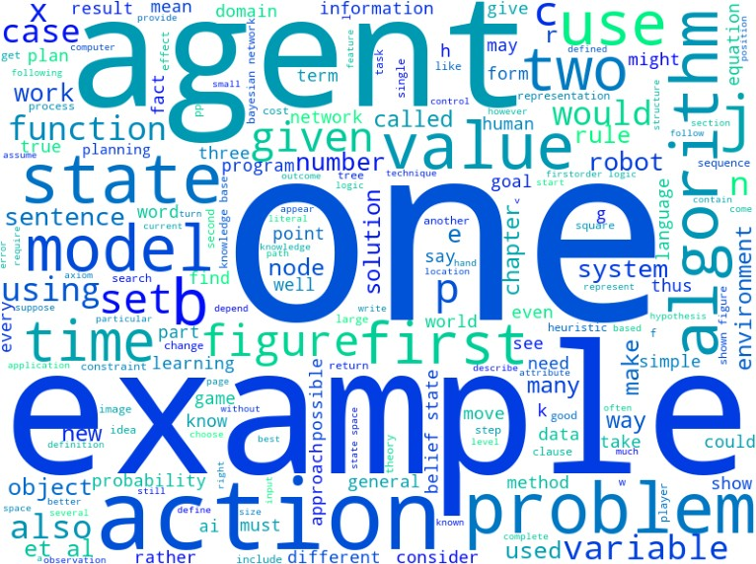

We used the WordCloud function to create word cloud of our dataset without stopwords After comparing both the word clouds we can observe that previously there were less

important words present in the word cloud but after filtering the dataset (i.e. removing the stop words), more important words are given importance in the word cloud.

### Analysing the frequencies after stopwords removal

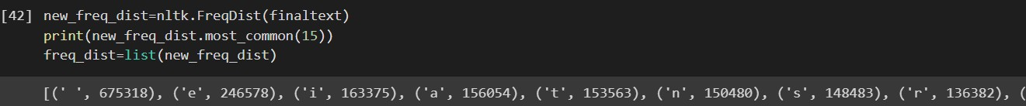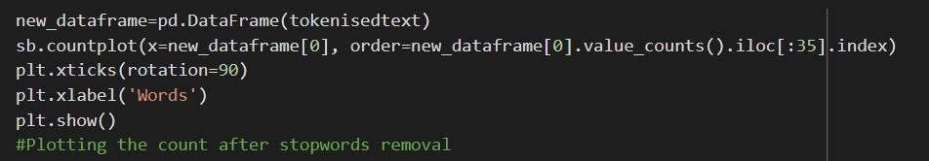

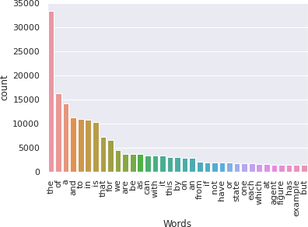

1. **Analysing the word length after removing the stop words**

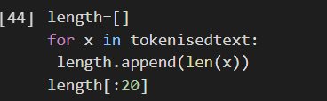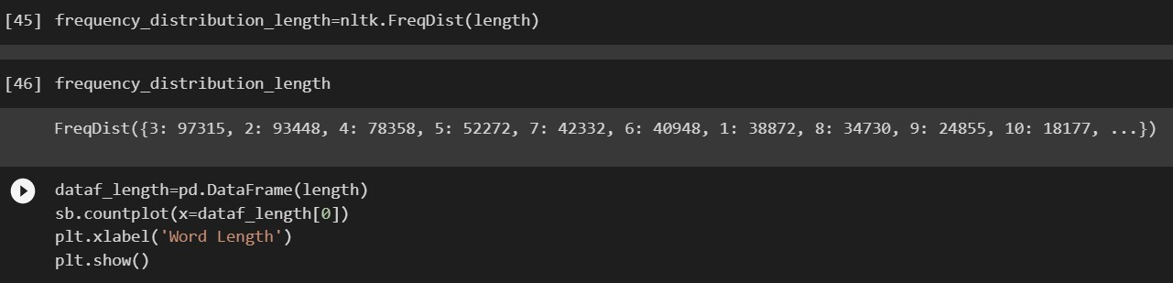

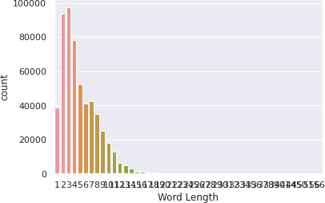

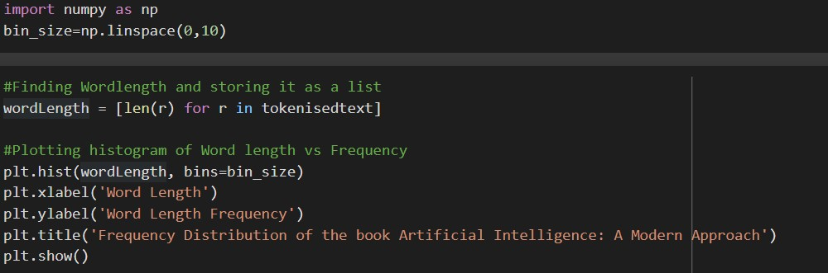

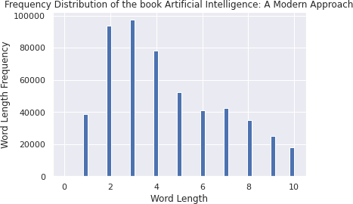

Relationship between the word length and frequency: Here, we tend to analyse a relationship between the word length and how many words with such word length occurs.

* We first associate a bin for the bar graph using “numpy” library
* Then using len() function we calculate the length of each token
* Then we plot a graph for frequency of such word lengths using matplotlib.pyplot

### Tagging the Parts of Speech using Treebank tagset

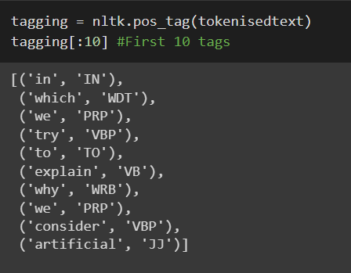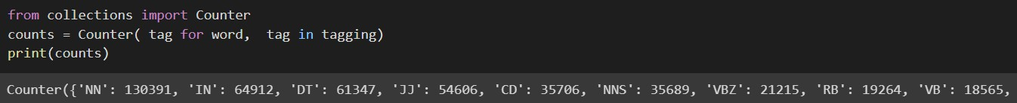

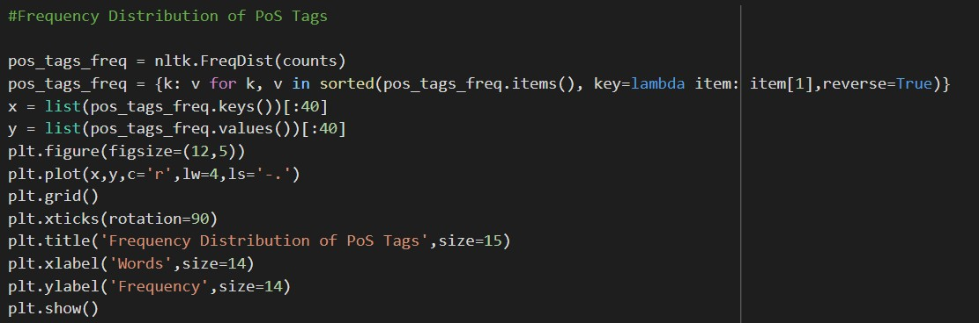

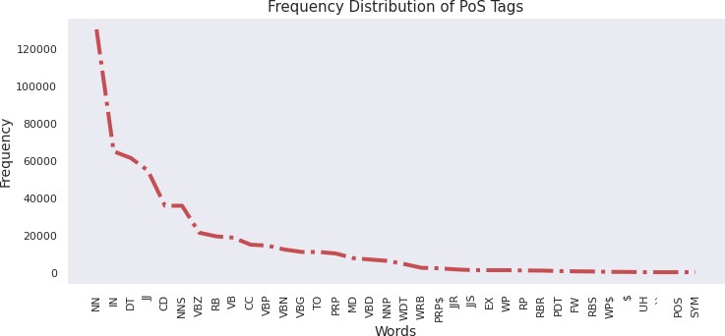

After we thoroughly clean our data, we proceed with the text processing part. Here, we have to assign appropriate Part-of-Speech Tags to the words. For this, we use the function “pos_tag( )” from the NLTK library of python.

1. The pos_tag() function uses the Penn Treebank Tag Set, which has 36 tags to assign from to the words.
2. The pos_tag returns a tuple consisting of the token and the tag.

**Inference**

We applied pos_tagging on the two books using pos_tag function. The pos_tag(words) function uses the Penn treebank as the default tag set as per official documentation.

In The textbook the most frequently occurring POS Tag is ‘NN’ with count 130391 followed by ‘IN’ having count 64912.

**Conclusion**

In this Round 1 of our project, we performed the tasks of word pre-processing, word tokenization, Word Cloud generation,POS tagging and also deduced many inferences from them about the books while also learning in the process.